From Parent HTML to Child HTML and javascript:



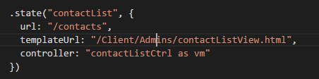

From javascript $Resource path to WebAPI address

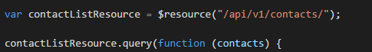

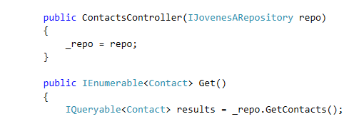

OR



Note Parameter must match I all 3 occurances

